Ideation Phase
Empathize & Discover

Date | 03 March 2026
Team ID | 69c0d687f58a227701cdf01d
Project Name | Streamlining Ticket Assignment for Efficient Supports Operations
Marks | 4 Marks

Empathy map canvas:
An Empathy Map Canvas is a user-centered tool used in the ideation phase to understand the thoughts, feelings, behaviors, and challenges of users involved in a system.
In the context of streamlining ticket assignment for efficient support operations, it helps analyze the experience of support agents (or users) by organizing insights into key areas such as:
- What users think and feel
- What they say and do
- What they see and hear
- Their pain points (problems)
- Their gains (needs and expectations)
This structured understanding helps teams identify real problems and generate effective, user-focused solutions.
Purpose in This Project:
In this project, the empathy map is used to:
- Identify issues in current ticket assignment
- Understand support agent challenges
- Discover improvement opportunities
- Support idea generation for automation and efficient

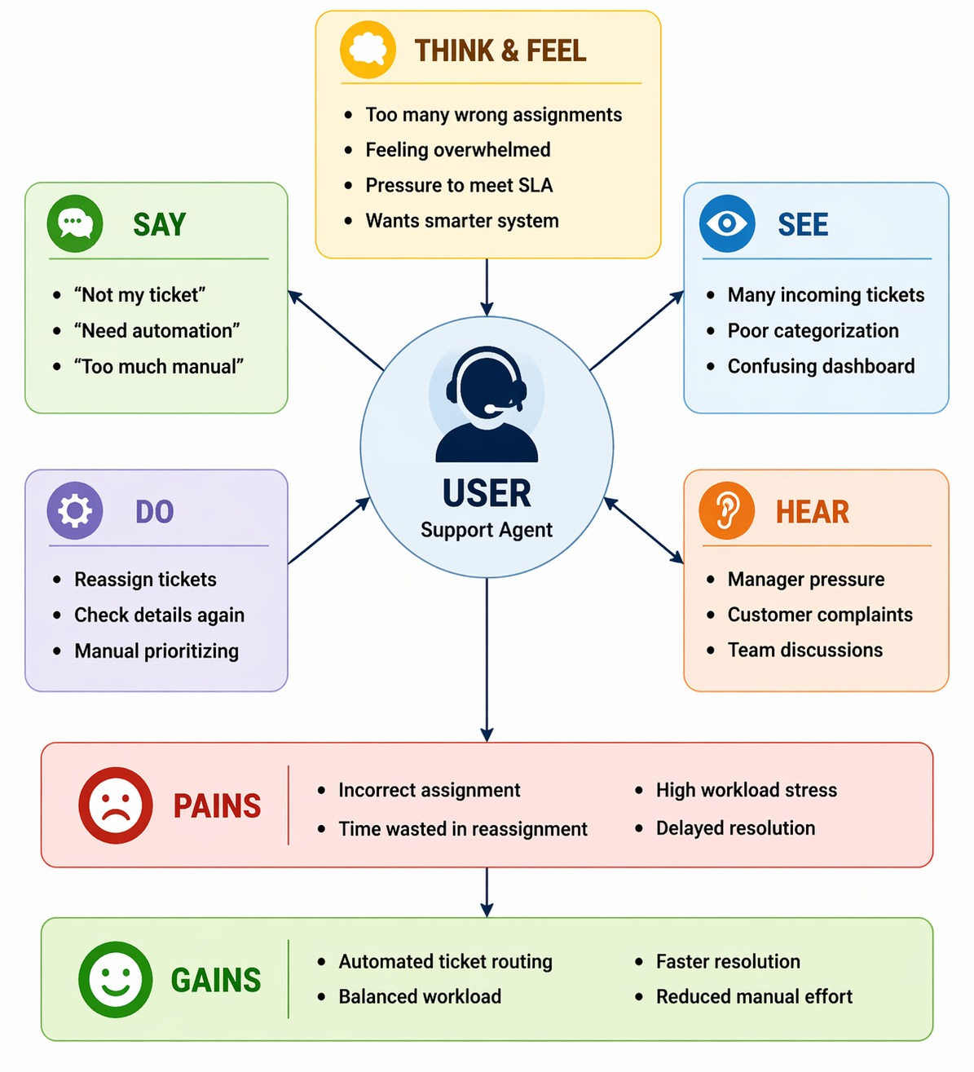
EMPATHY MAP

An Empathy Map Canvas is a framework used in the ideation phase to understand user behavior and needs, enabling the design of efficient and user-centric ticket assignment solutions.

